Google “Ernie”

It will take you to Embry-Riddle Login

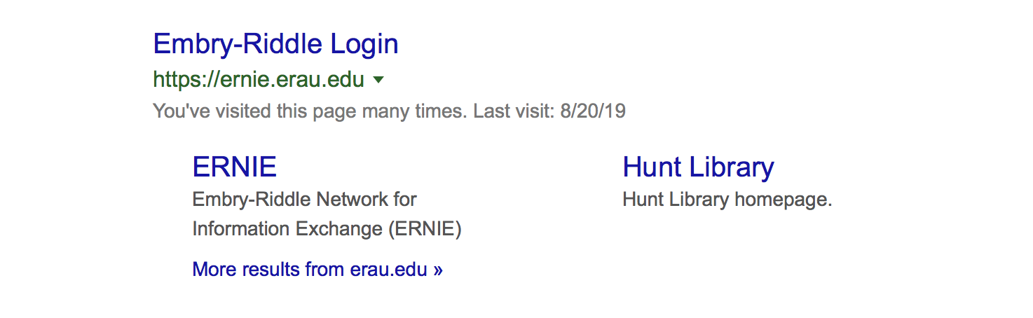
LOGIN

marta114

myname12345!!

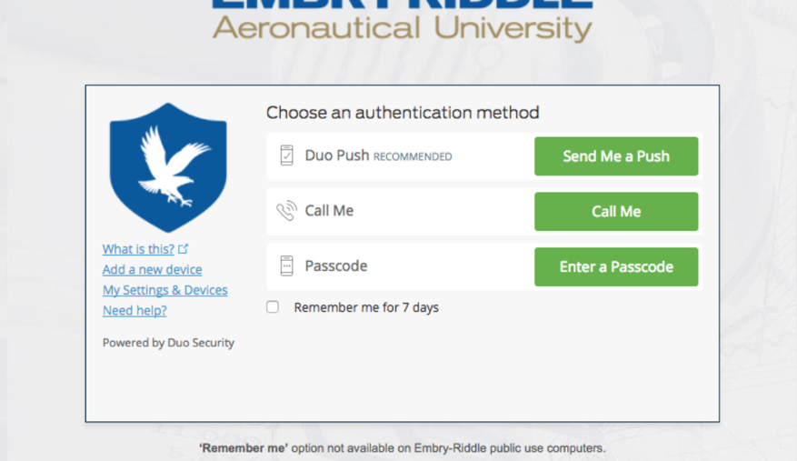

THEN: Press “Call Me”

It will call my phone, and I will let you in.

Where to Find Assignments/Quiz: This is how to navigate to the (2) Assignments and (1) Quiz.

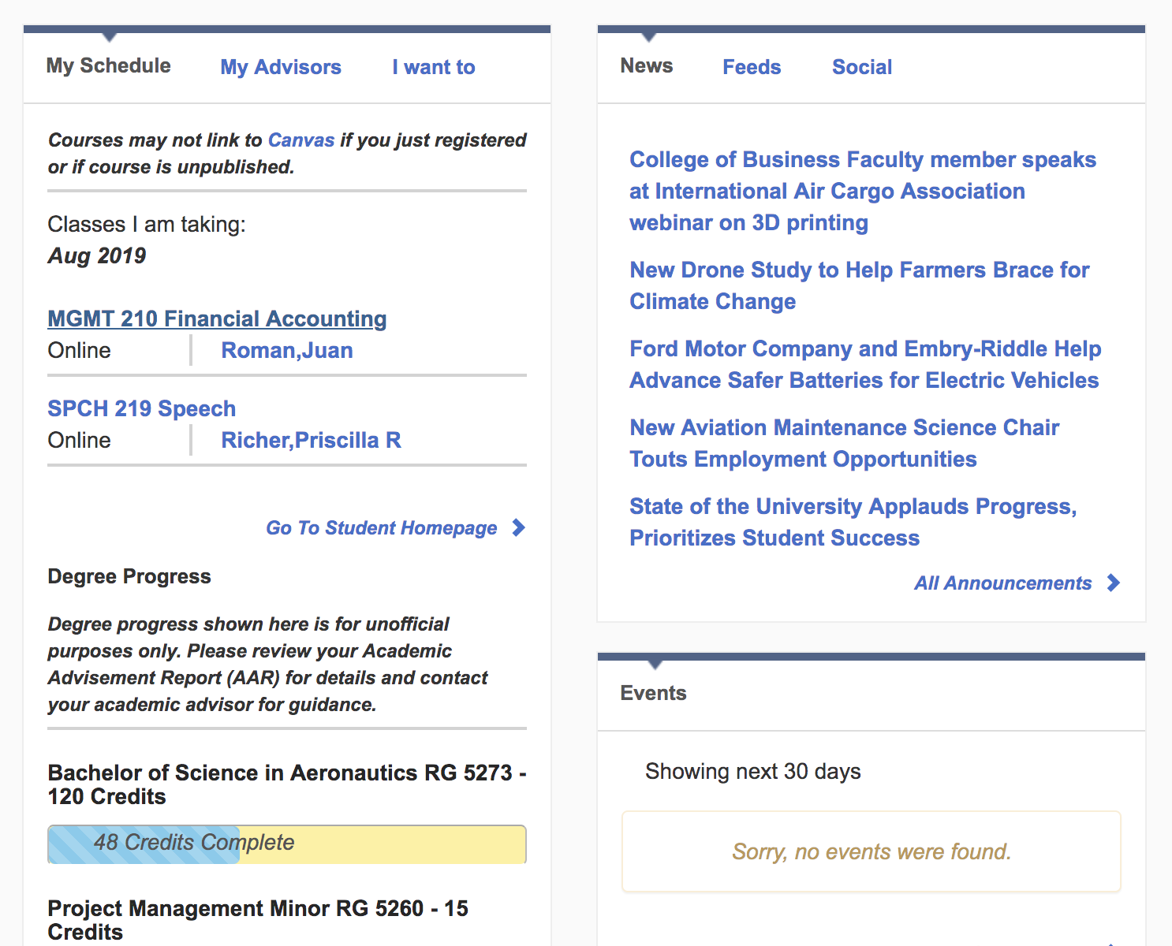

Chose MGMT 210 Financial Accounting
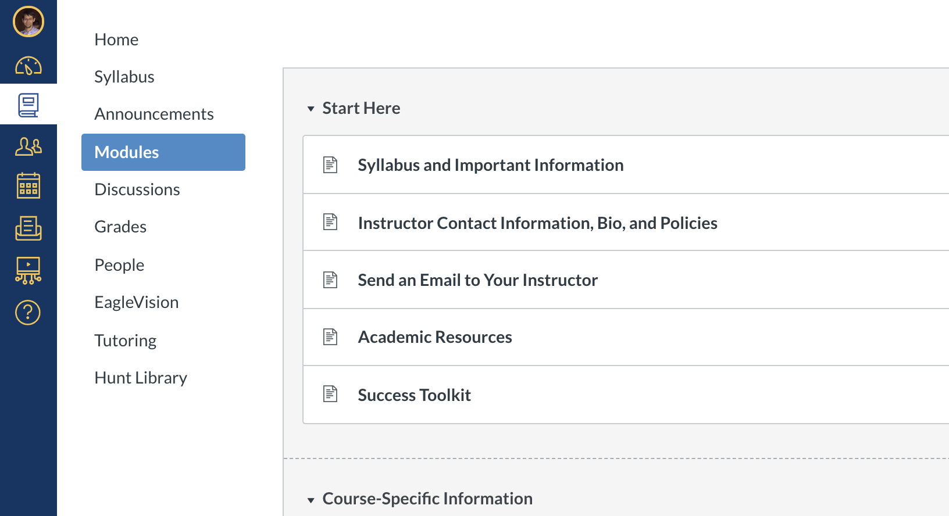

Chose Modules

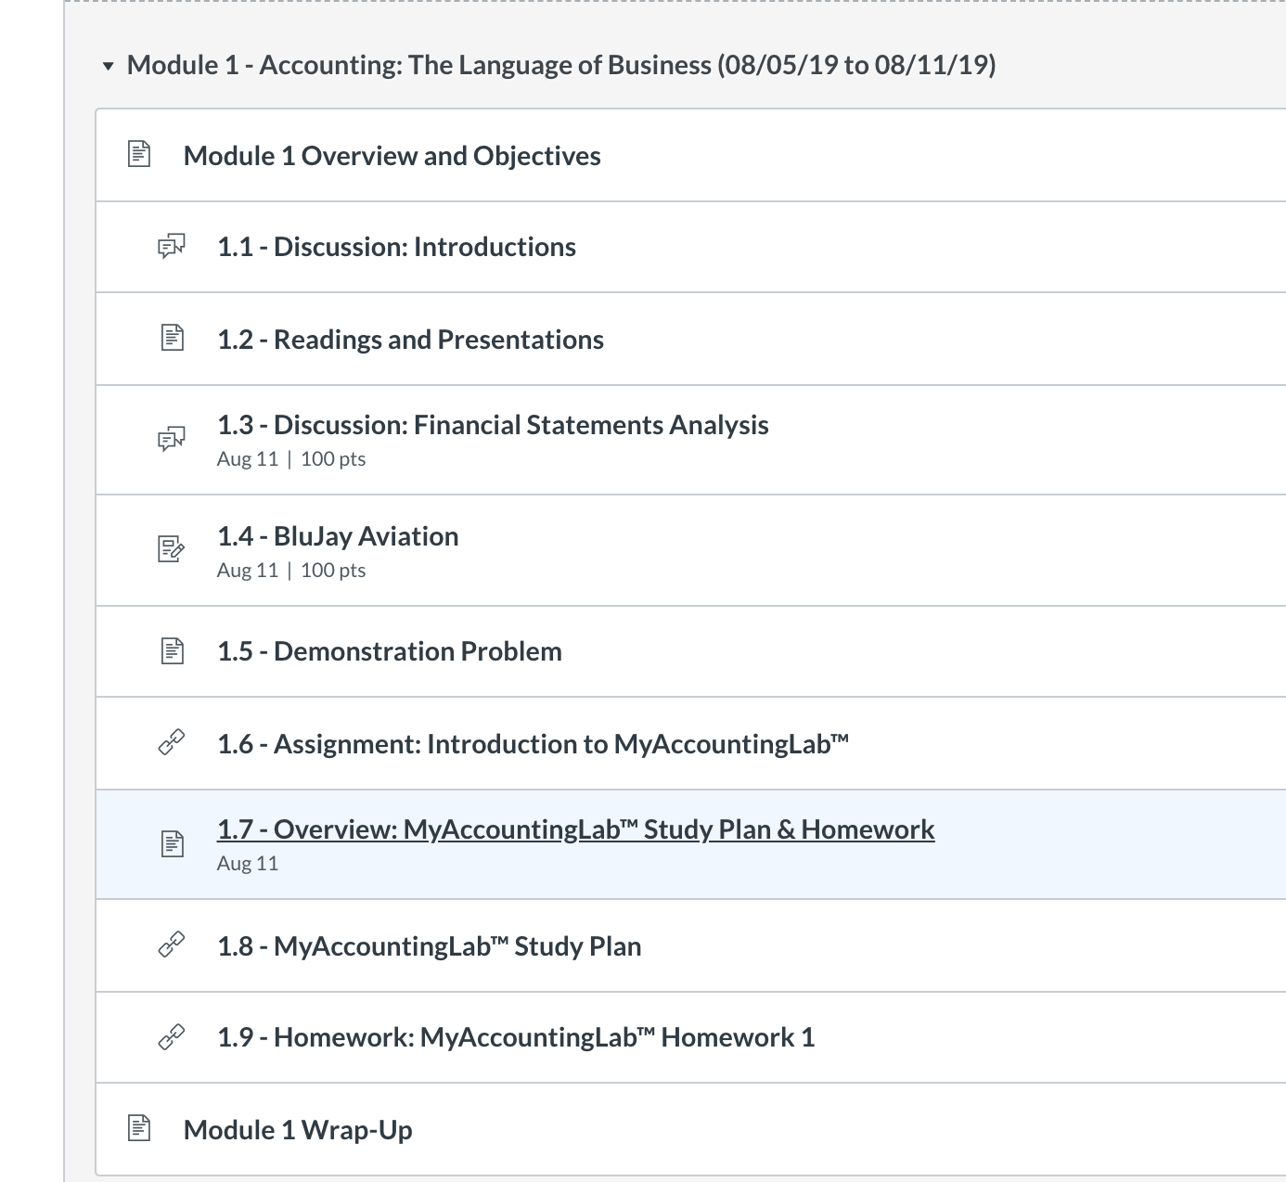

Chose 1.7 Overview

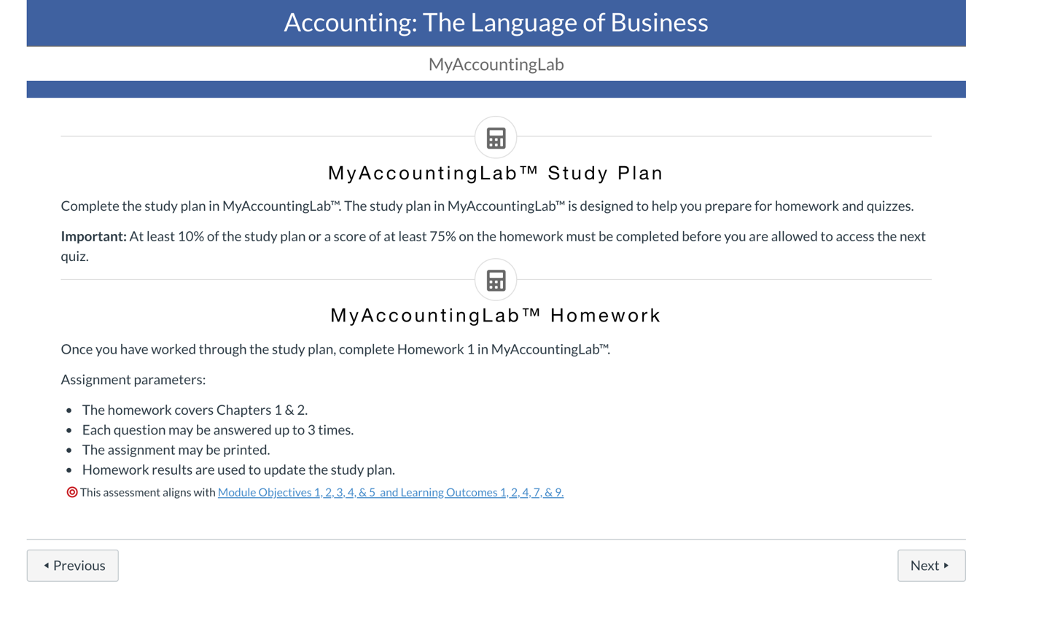
Chose: NEXT

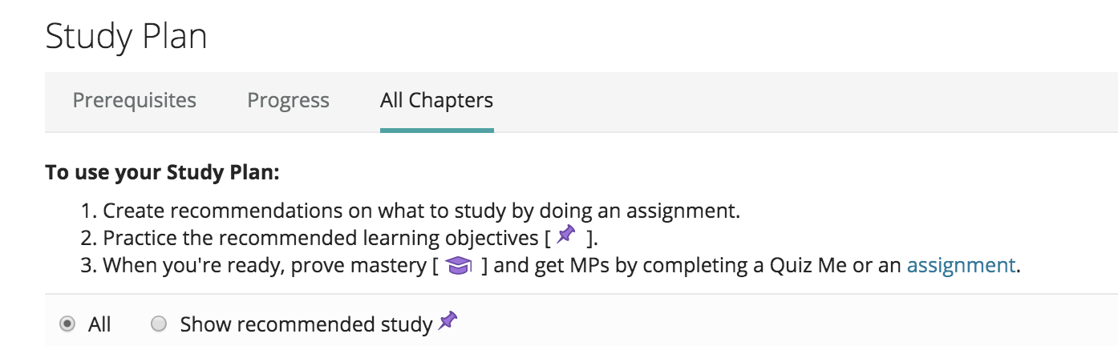

Chose: All Chapters

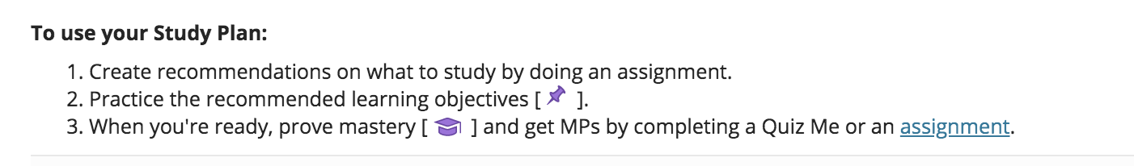

Chose: assignment

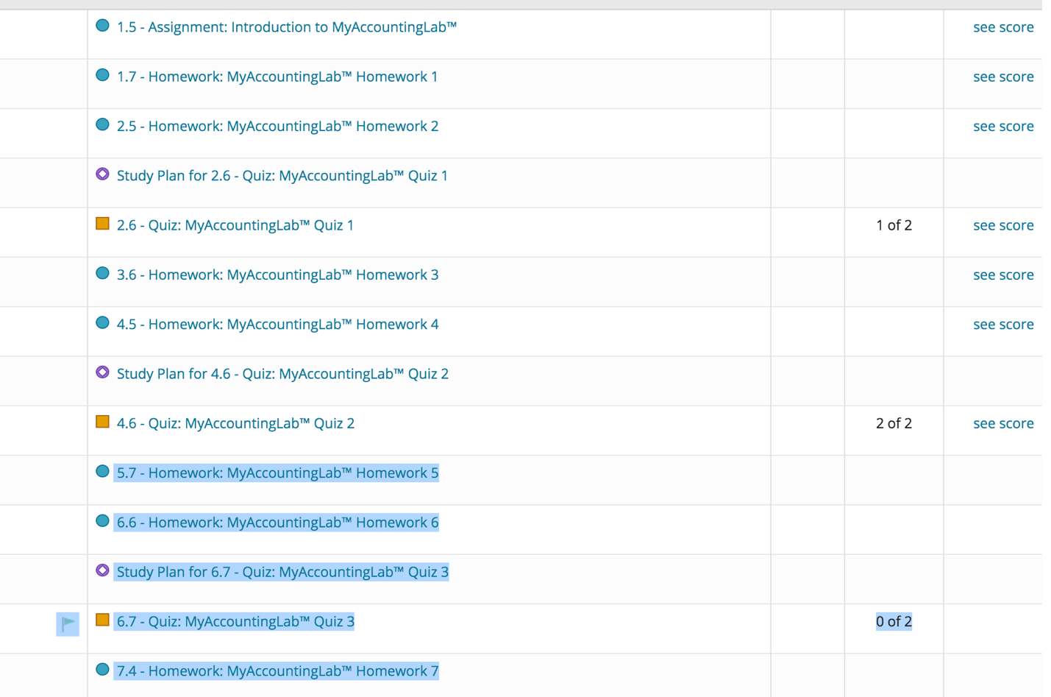

2 HW + 1 Quiz. (4 Easy questions I already uploaded on)
Study Plan for 6.7 MyAccountingLab - Don’t do this, not needed!

What you need to Do:
5.7 Homework: MyAccountingLab Homework 5
6.6 Homework: MyAccountingLab Homework 6
6.7 Quiz: MyAccountingLab Quiz 3

Optional, if you want – We will discuss Bonus Pay.

7.4 Homework: MyAccountingLab Homework 7

Remember if you have an account with Chegg.com. or CourseHero.com, it helps with some questions.

You have 2 attempts for quiz: Good luck, and Thanks a lot!!

You can get extra help by clicking: Question Help, then Help Me Solve This.

